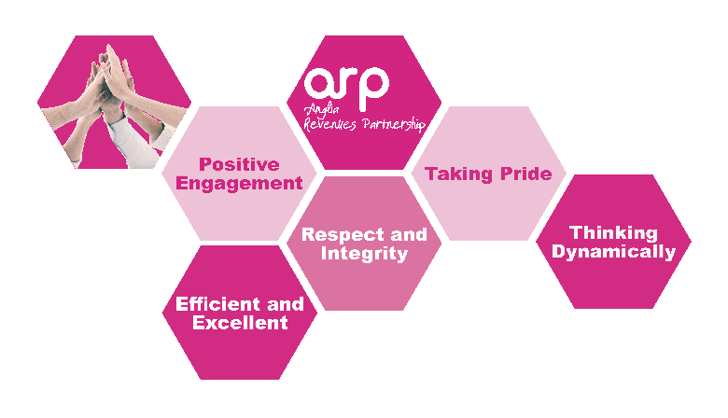
PERSON SPECIFICATION

Job Title: Council Tax Billing Officer
Service Area: Revenues and Benefits
Team: Billing and Benefits
 | Essential | Desirable
Qualifications & Experience | Good general education – GCSE grades A-C or 1-5 in English and Maths or relevant qualifications/experience | Recent experience of working in a busy office environment or have relevant qualifications in this field  IRRV Technician Grade
Knowledge | Knowledge of computer packages, including Microsoft Suite and have sufficient knowledge and skill to be able to use computers effectively | Working knowledge of Academy and Civica or other revenues processing and/or document imaging systems  Demonstrate knowledge of Council Tax and or Local Council Tax Reduction regulations.  A good understanding of GDPR regulations
Skills | Ability to work accurately whilst understanding the importance of meeting strict deadlines  Must be able to work to personal and team targets  Ability to gather and analyse facts and information
Delivering excellent Customer Service | Demonstrate experience or understanding of customer care  Demonstrate ability to deal with customer enquiries in an appropriate, diplomatic and professional manner  Be able to remain calm during stressful circumstances. | Customer Care Training
Health, Safety and Welfare | Able to demonstrate good general understanding of Health, Safety and Welfare policies and procedures.  Demonstrate ability to achieve a good work live balance for self and team
Striving for Continuous Improvement | Willing to learn and improve with a commitment to a learning culture  Able to give examples of flexible and positive response to change
Diversity and Equality | Ability to understand the concept diversity and respect for others and be committed to these issues
Communicating effectively | Good level of interpersonal and communication skills  Effectively communicates relevant information to others using the most appropriate method  Able to respond to varying levels of understanding from customers
Attitude | Must be able to self-motivate and encourage constructive relationships  Be an effective team player and work flexibly within a team  Have a positive desire to achieve results  Can work effectively under pressure and use own initiative

